Rural areas lead N.Y. aging trend
State’s largest cities have younger populations
BY MICHAEL HILL The Associated Press

May 13, 2011
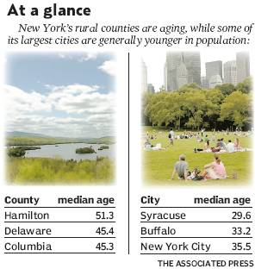
New York state is getting older, and rural areas are leading the way.

Demographic figures released Thursday by the U.S. Census Bureau show the median age in New York state jumped to 38 in 2010 from 35.9 a decade before. The aging trend was especially pronounced in rural counties — a phenomenon with far-reaching policy implications as local officials grapple to provide health care and other services to an older, more far-flung population.

“Transportation is probably one of the biggest nuts to crack,” said David McNally, senior manager of advocacy for AARP in New York. “The distances involved in this stuff make this much more difficult.”

Populations in New York state and around the country are graying as baby boomers edge into retirement age and people live longer. With demographic data on half the states released by the Census as of Thursday, New York is in the middle of the pack, age-wise.

The numbers become more striking when comparing New York’s cities to its rural areas. The dozen counties with the highest median ages in New York were largely rural.

Sparsely populated Hamilton County in the Adirondacks — where more than one out of every five people are over age 64 — has a state-high median age of 51.3. The median age there increased by almost six years over the decade. The second-oldest county in New York is Delaware (45.4), east of Binghamton, followed by Columbia County (45.3).

The numbers provide more evidence of a long-term trend bedeviling many rural areas, where local officials have been struggling to stem the exodus of younger, college-educated residents for other places with more opportunities. Some of these more picturesque areas, such as Hamilton County, are also home to a fair number of retirees.

“Younger people are leaving because of no jobs and there are those retirees that move in that have built their second homes,” said Bessie Savage of the Office for the Aging for Warren and Hamilton counties.

The state’s largest cities are generally younger. Census data show that the median age in New York City — a magnet for young people and immigrant families — was 35.5 in 2010. The median age for Buffalo was 33.2; Rochester, 30.8; Yonkers, 37.6; and Syracuse, 29.6.

The youngest counties in New York were Tompkins (29.8), a rural county that is home to Cornell University and Ithaca College, and Jefferson (32.6), home to thousands of soldiers stationed at Fort Drum and their families.

The Census Bureau previously reported that the state’s population grew by 2 percent over the past decade to just under 19.4 million. The new report gives age breakdowns that show while the number of adults grew by 5 percent over the decade, the under-18 population statewide fell by about 8 percent.

Rolf Pendall, director of the Urban Institute’s Metropolitan Housing and Communities Policy Center, said that kind of reduction in younger people from 2000 to 2010 is not unusual given the demographic bulge of the baby boom.

“It’s simply a consequence of the baby boomers being well past their fertility period,” and the children of those baby boomers aren’t having kids yet, he said.

The number of 55- to 64-yearolds — an age group representing baby boomers — grew by 36 percent statewide.

